***NAME : Himanshu Dixit***

***ENROLL NO. : B64178***

***BATCH : B10***

***Software Development Fundamentals – I (15B11CI111)***

***ODD 2021***

***Tutorial Sheet - 2***

***Q1.***  *Find out the minimum count of races required to identify three fastest horses, if count of horses is 25 and at a time only 5 horses can participate in a race. Also, you do not have the accessibility to watches.*

***SOLUTION:***

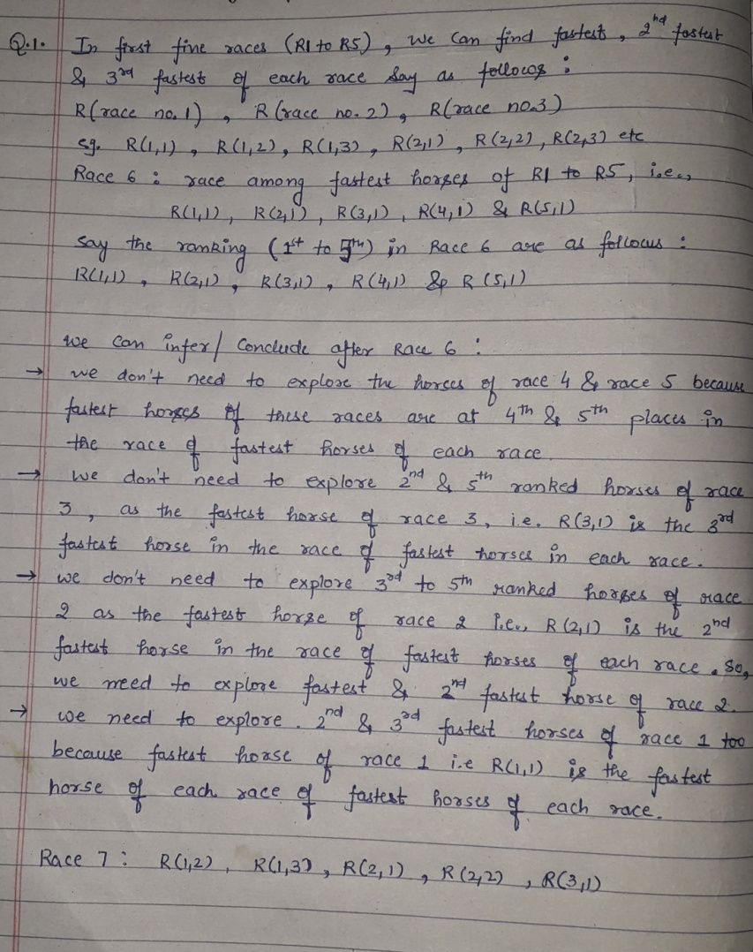

***Q2.***  *Let us modify the Fake Coin puzzle as follows: 8 coins are given, out of which 1 coin is fake; you do not know whether the fake coin is lighter or heavier than the genuine coin. You have accessibility of two pan weighing machine without weights. Identify the minimum count of required weighing to identify the fake coin.*

***SOLUTION:***

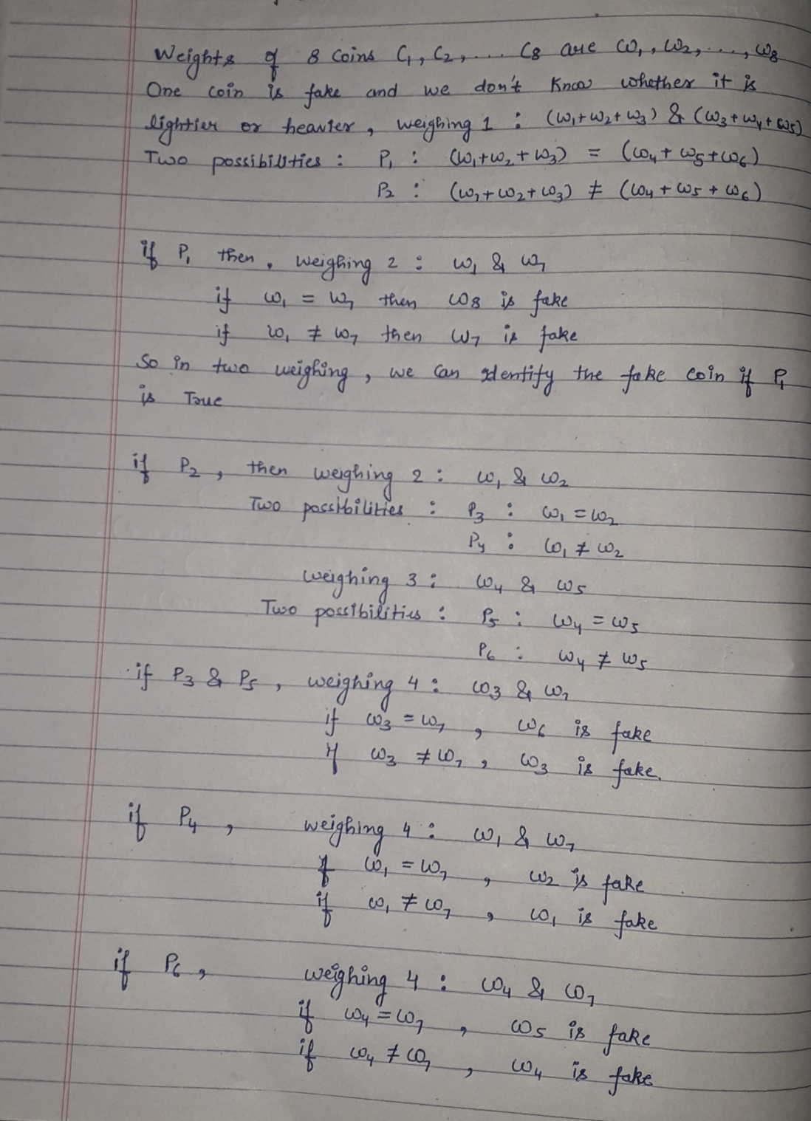

***Q3.***  *Constrained with, no accessibility to watches, draw the flow chart to find out the minimum count of races required to find three fastest horses, if count of horses is 25 and at a time only 5 horses can participate in a race*

***SOLUTION:***

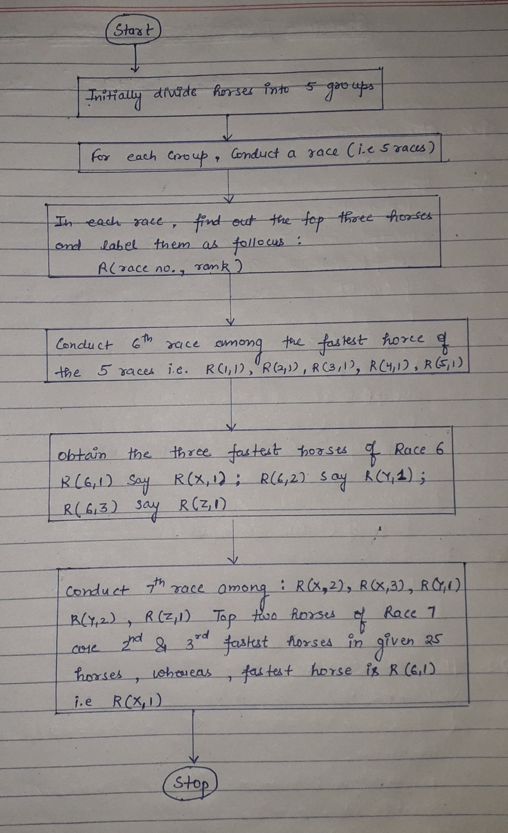

***Q4.***  *You have three jugs/containers (without marker) named as A, B, and C with capacities as 8 litres, 5 litres, and 3 litres respectively. The 8 litres jug is full of water whereas other two are empty jugs. Without weighing the jugs, it is desired to put 4 litres water into jug B with minimum number of steps*

***SOLUTION:***

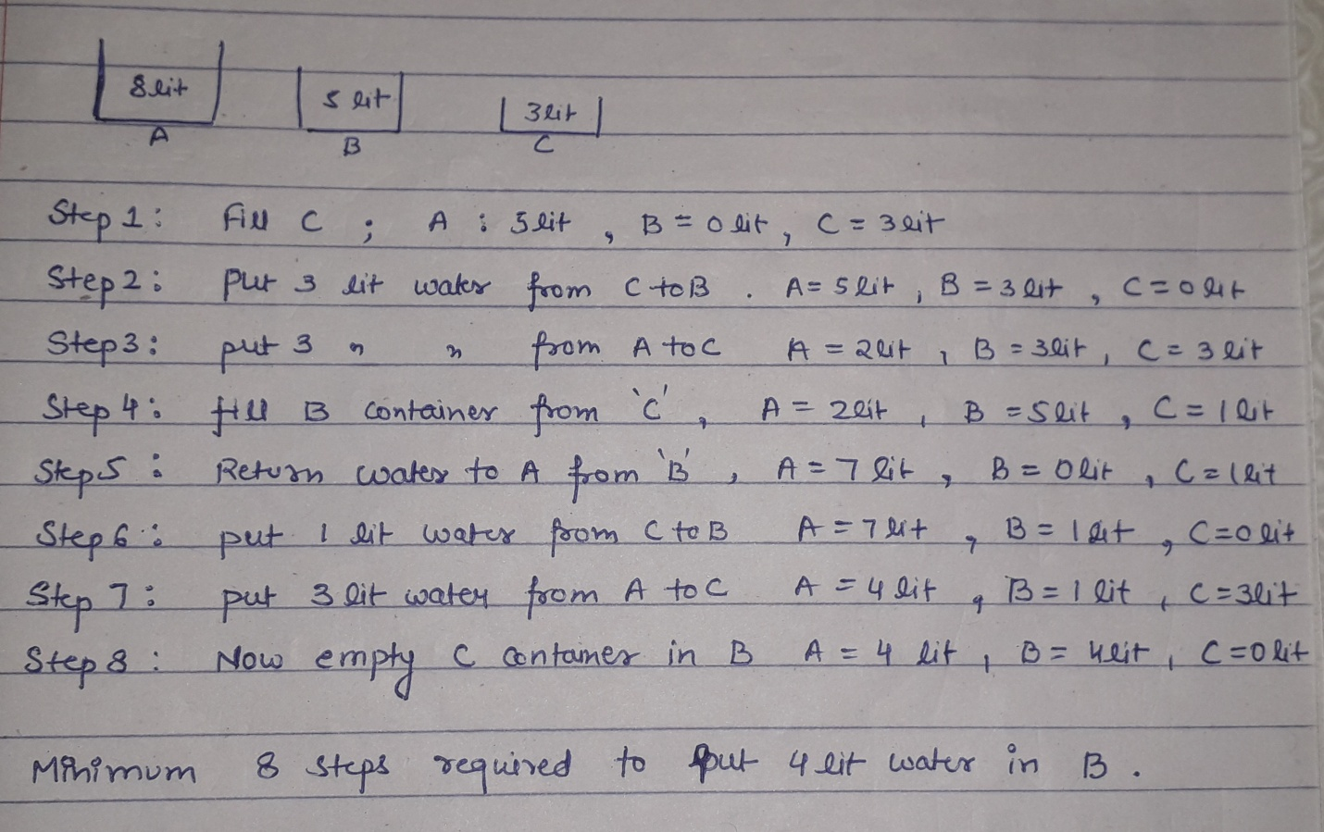

***Q5.***  *Covering all the requirements of the Snake & Ladder game, draw the flow chart*

***SOLUTION:***

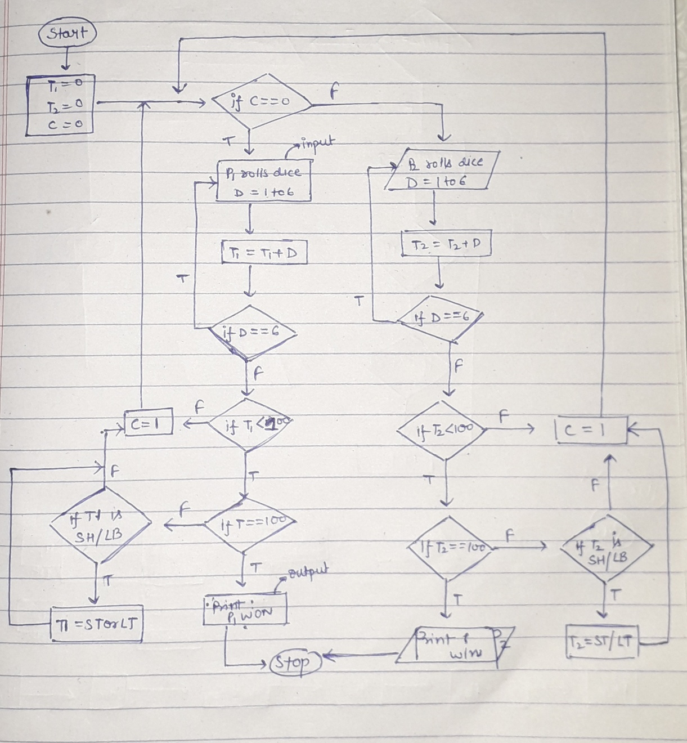

***Q6.***  *Draw the flow chart to verify whether the user inputted number is a prime number or not*

***SOLUTION:***

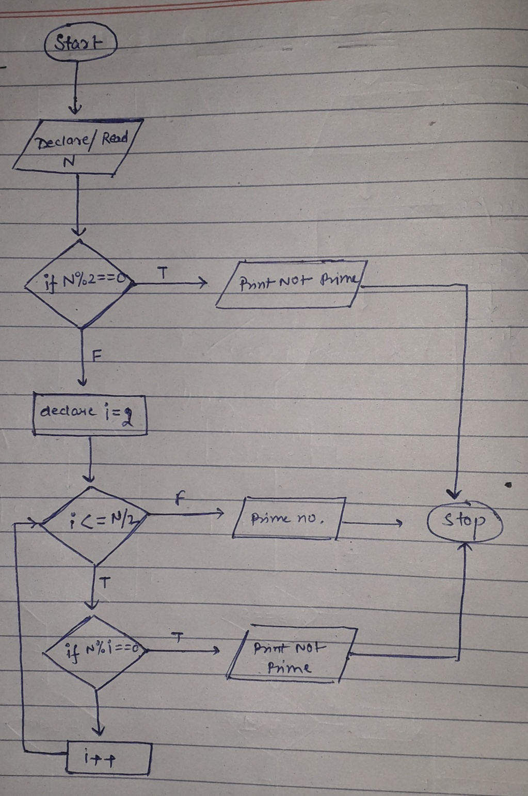

***Q7.***  *It is desired to compute the average and total marks of a student in five subjects. Draw the flow chart and write C program to input the marks obtained in five subjects and display the average and total marks*

***SOLUTION:***

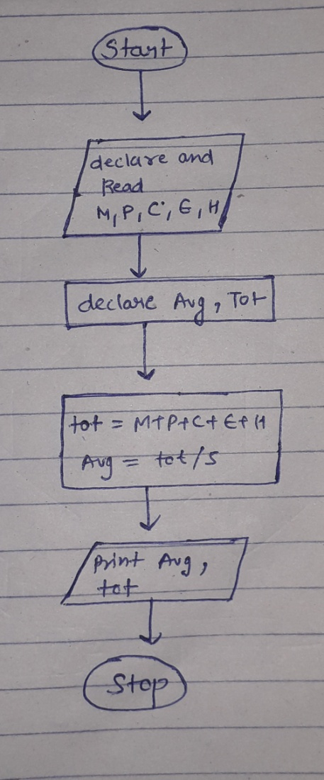

#include <stdio.h>

int main()

{

float m,h,s,e,c,tot;

float per;

printf("Enter marks in maths: ");

scanf("%f", &m);

printf("Enter marks in hindi: ");

scanf("%f", &h);

printf("Enter marks in science: ");

scanf("%f", &s);

printf("Enter marks in english: ");

scanf("%f", &e);

printf("Enter marks in computer: ");

scanf("%f", &c);

tot=m+h+s+e+c;

per=tot/5;

printf("the total marks is:%f\n", tot);

printf("the percentage is:%f%%\n",per);

return 0;

}

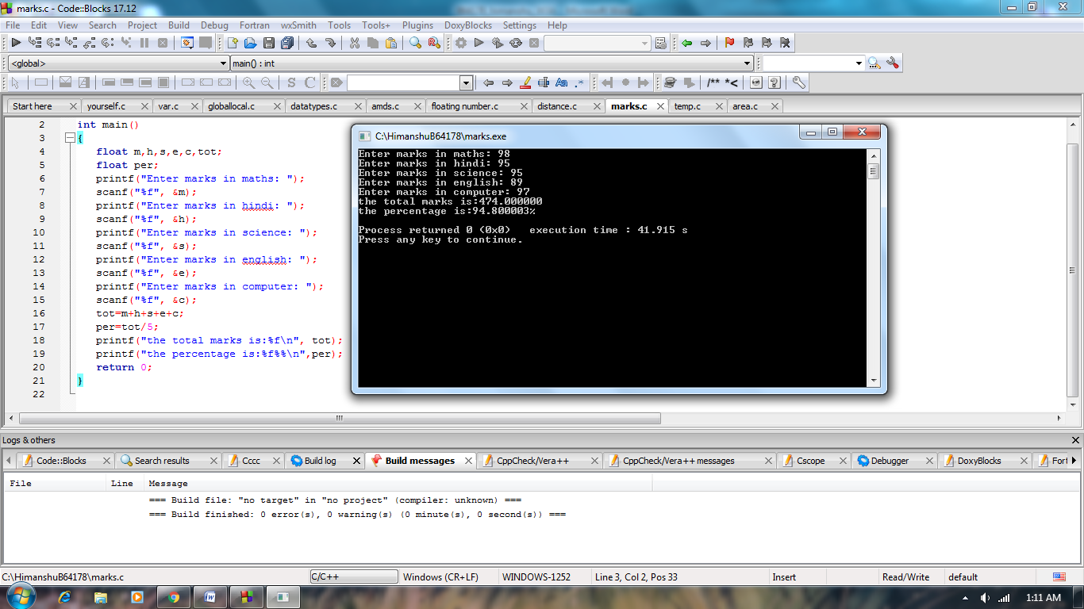

***Q8.***  *Draw the flow chart and write C program to swap the values of two variables without using the third variable*

***SOLUTION:***

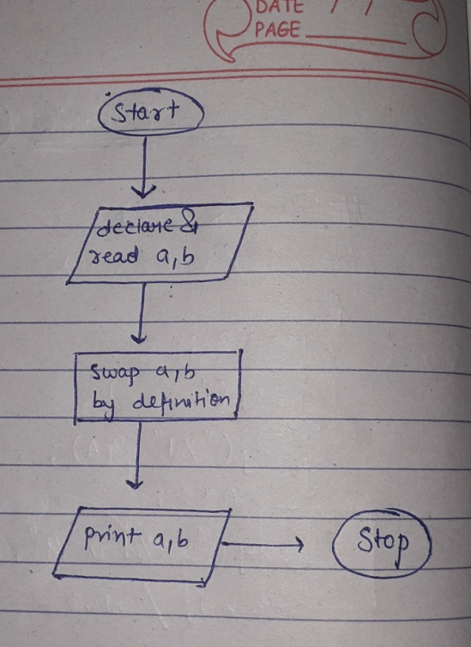

#include<stdio.h>

int main()

{

int V1, V2;

printf("Enter two variables");

scanf("%d%d", &V1, &V2);

V1 = V1+V2;

V2 = V1-V2;

V1 = V1-V2;

printf("After swapping V1 = %d and V2 = %d", V1, V2);

return 0;

}

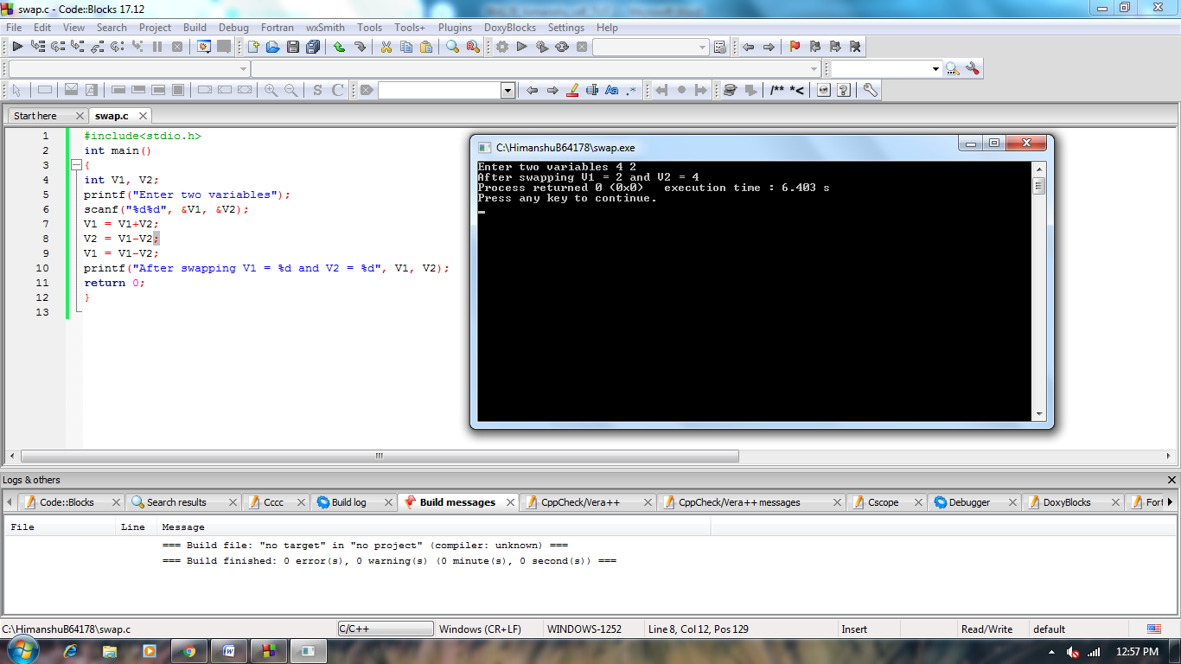

***Q9.*** *Let us create a magic square of3×3 square grids by placing distinct numbers in the range between 5 and 13. Which one of the following is the sum of the values present in each column or each row, or each corner to corner diagonal?*

1. *38*
2. *32*
3. *30*
4. *None of the listed options*

***SOLUTION:***

